Chapter 11-[Induction](https://mfleck.cs.illinois.edu/building-blocks/version-1.3/induction.pdf)

Monday, January 2, 2023

4:53 PM

***Induction:***

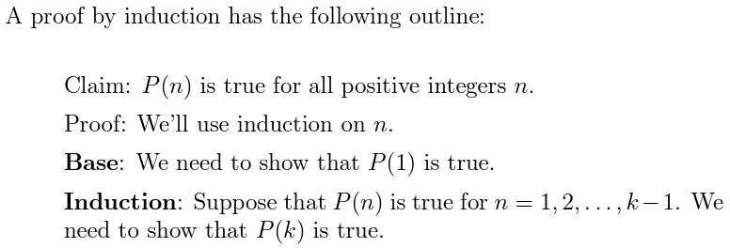

(Basically writing a "recursive" proof)

*Manually calculate/show/proof the Base value, then write the induction proof to show that the "next" value (k+1) can also be proven* ***given that the "current" value (k) is already proven***

Example:



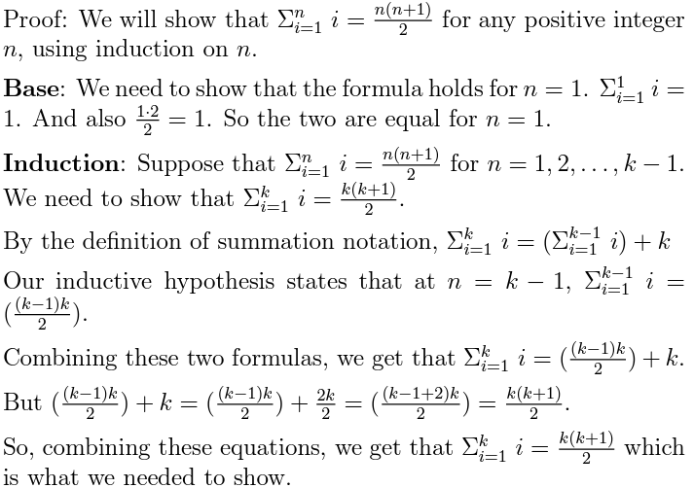

*(only really works for natural numbers or infinite subsets of natural numbers like integers)*

Note that the P(k) must be a true of false **statement**, **NOT** a formula that gives a number.

P must also depend on k, and k is known as the induction variable.



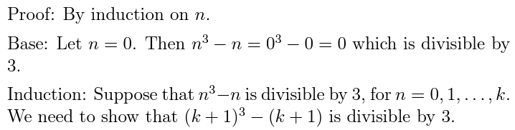

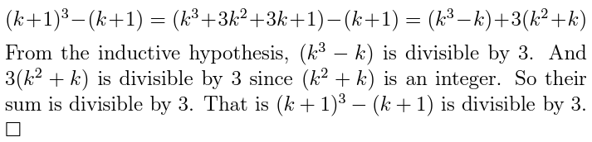

Sometimes there is more than 1 base case written out just for good measure.

The Right Triominoes Example:

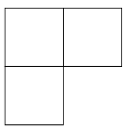

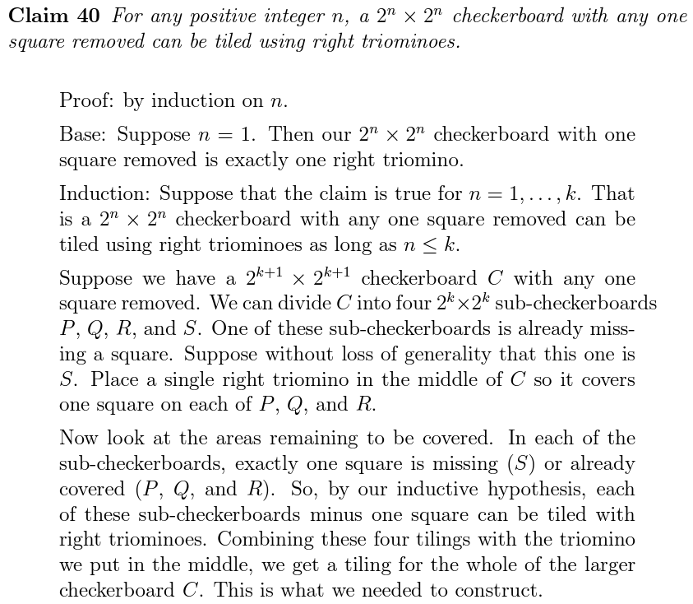

*Try to find ways to relate the P(k+1) part back to the P(k) and the definition of P*

*(P is the equation/statement/algorithm/thing that is in the claim)*

The Greedy Graph Coloring Algorithm:



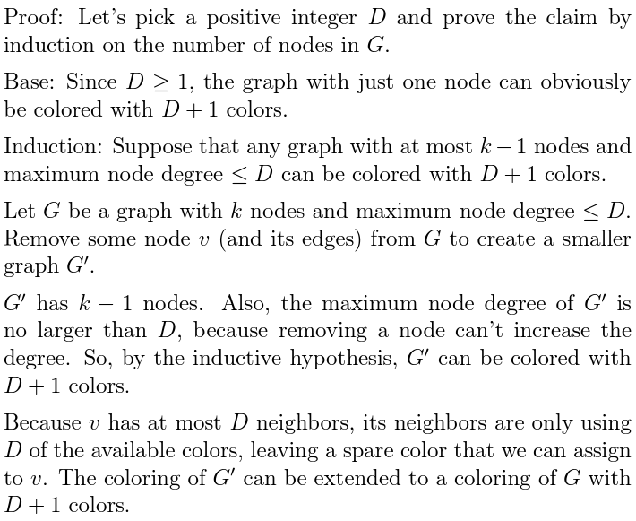

So it just goes through all the nodes, at every node checks and see what colors have been assigned to its neighbors. If there is a previously used color not assigned to a neighbor, we re-use that color. Otherwise, we assign a new color to that node and move on.

*(Note that it is not the most efficient, since D+1 is the upper bound, and some different coloring method can easily color the same graph with less colors)*

A ***Strong Inductive Hypothesis*** is when the inductive step assumed that P(n) is true for all previous steps of n from the base up to k − 1.

*When the inductive step requires more than 1 previous value (not enough info from just k-1), you usually need a Strong Inductive Hypothesis and sometimes prove more than 1 base case to ensure that* ***all*** *previous steps were true.*

A ***Weak Inductive Hypothesis*** is when the inductive step **only** assumes that P(k-1) is true.

You can use a weak inductive hypothesis when k-1 gives enough info to finish the proof.

*The safe way (for dummies like me) is just to use Strong Inductive Hypothesis everywhere.*